**ARDUINO IOT BASED MODULES**

For Remote access and Remote monitoring, we are going to use this Iot based modules. Where ever we go we keep on monitoring our data used by the WIFI, and the water dispensed and filled by the water purifier and we get a clear-cut information of vacuum cleaner how much dust has been filled in the vacuum and the data is stored in the cloud.in this way, in this project we are going to get a remote access and remote monitoring of a machine using Arduino Iot based modules Firstly, let us know about the Iot modules in Arduino.

**Arduino Internet of Things Modules**

Make connected devices easily with one of these IoT products and open your creativity with the opportunities of the world wide web. These boards are compatible with the Arduino Cloud which allows to collect data in dashboards, control devices from a mobile app and update firmware over a network connection.

Types of Arduino Iot modules:

* Arduino nano 33 Iot
* MKR FOX 1200
* MKR WAN 1300
* Arduino MKR Wan 1310
* MKR GSM 1400
* MKR WIFI 1010
* MKR NB 1500
* Arduino MKR1000
* Arduino NANO RP2040 Connect
* MKR Iot bundle
* OPLA Iot kit
* Arduino Portenta H7

1. **Arduino nano 33 Iot :**

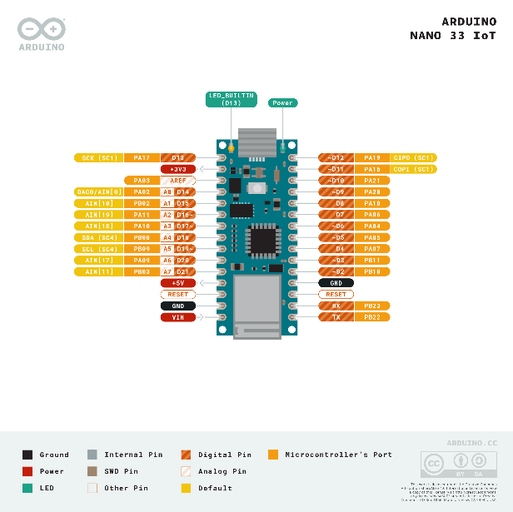

The Arduino Nano 33 IoT is Arduino's smallest board to get started with Internet of Things (IoT). Using the popular Arm® Cortex®-M0 32-bit SAMD21 processor, it also features the powerful u-blox NINA-W102 Wi-Fi module and the ECC608A crypto-chip for security.

This small, robust and powerful board has WIFI and Bluetooth connectivity that combined with its low power architecture makes it a practical and cost-effective solution for your connected projects.

The microcontroller on the Arduino Nano 33 IoT runs at 3.3V, which means that you must never apply more than 3.3V to its Digital and Analog pins. Care must be taken when connecting sensors and actuators to assure that this limit of 3.3V is never exceeded. Connecting higher voltage signals, like the 5V commonly used with the other Arduino boards, will damage the Arduino Nano 33 IoT.

To avoid such risk with existing projects, where you should be able to pull out a Nano and replace it with the new Nano 33 IoT, we have the 5V pin on the header, positioned between RST and A7 that is not connected as default factory setting. This means that if you have a design that takes 5V from that pin, it won't work immediately, as a precaution we put in place to draw your attention to the 3.3V compliance on digital and analog inputs.

**5V on that pin is available only when two conditions are met:**

you make a solder bridge on the two pads marked as VUSB and you power the NANO 33 IoT through the USB port. If you power the board from the VIN pin, you won't get any regulated 5V and therefore even if you do the solder bridge, nothing will come out of that 5V pin. The 3.3V, on the other hand, is always available and supports enough current to drive your sensors. Please make your designs so that sensors and actuators are driven with 3.3V and work with 3.3V digital IO levels. 5V is now an option for many modules and 3.3V is becoming the standard voltage for electronic ICs.

|  |  |  |
| --- | --- | --- |
| **Board** | **Name** | Arduino® Nano 33 IoT |
| **SKU** | ABX00027 |
| **Microcontroller** | SAMD21 Cortex®-M0+ 32bit low power ARM MCU | |
| **USB connector** | Micro USB | |
| **Pins** | **Built-in LED Pin** | 13 |
| **Digital I/O Pins** | 14 |
| **Analog input pins** | 8 |
| **PWM pins** | 5 |
| **External interrupts** | All digital pins |
| **Connectivity** | **Wi-Fi** | Nina W102 uBlox module |
| **Bluetooth** | Nina W102 uBlox module |
| **Sensors** | **IMU** | LSM6DS3 |
| **Communication** | **UART** | Yes |
| **I2C** | Yes |
| **SPI** | Yes |
| **Power** | **Circuit operating voltage** | 3.3V |
| **Input voltage (limit)** | 21V |
| **DC Current per I/O Pin** | 15 mA |
| **Clock speed** | **Processor** | SAMD21G18A 48MHz |
| **Memory** | **SAMD21G18A** | 256 KB SRAM, 1MB flash |
| **Nina W102 uBlox module** | 448 KB ROM, 520KB SRAM, 2MB Flash |
| **Dimensions** | **Weight** | 5gr |
| **Width** | 18 mm |
| **Length** | 45 mm |

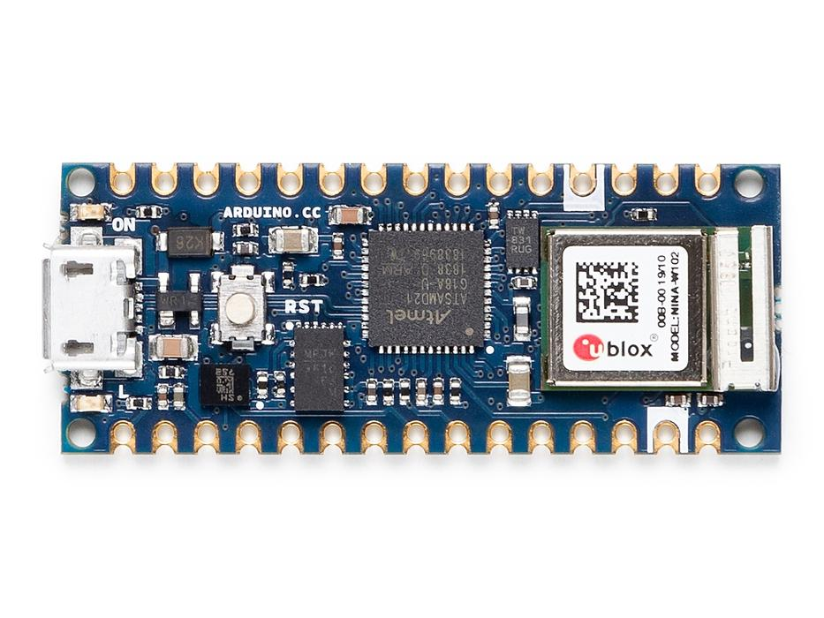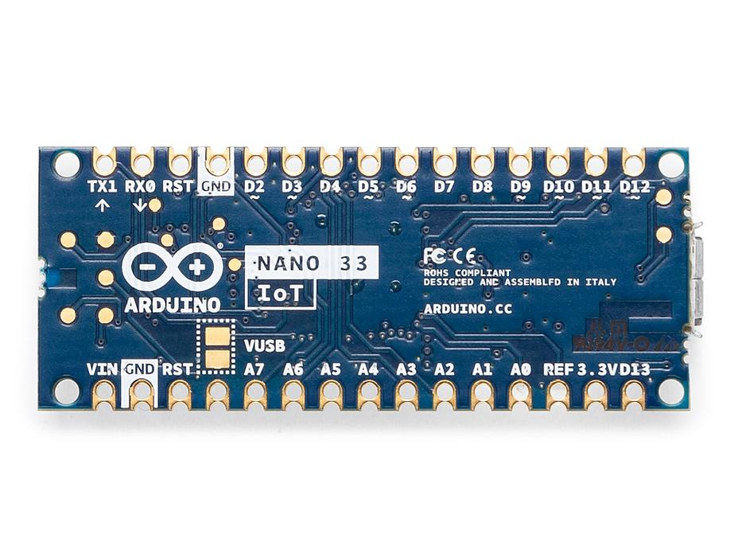

**WIFI and Arduino Iot cloud :**

At Arduino we have made connecting to a WIFI network as easy as getting an LED to blink. You can get your board to connect to any kind of existing WIFI network, or use it to create your own Arduino Access Point. The specific set of examples we provide for the Nano 33 IoT can be consulted at the [WIFI NINA library reference page](https://www.arduino.cc/en/Reference/WiFiNINA).

It is also possible to connect your board to different Cloud services, Arduino's own among others. Here some examples on how to get the Arduino boards to connect to:

* **Arduino's own IoT Cloud:** Arduino's IoT Cloud is a simple and fast way to ensure secure communication for all of your connected Things. Check it out [here](https://www.arduino.cc/en/IoT/HomePage)
* **Blynk:** a [simple project](https://create.arduino.cc/projecthub/officine-innesto/control-your-iot-cloud-kit-via-blynk-ec6a16) from our community connecting to Blynk to operate your board from a phone with little code
* **IFTTT:** see an in-depth case of [building a smart plug](https://create.arduino.cc/projecthub/Avilmaru/smart-plug-with-arduino-mkr-wifi-1010-63cb25?ref=tag&ref_id=ifttt&offset=4) connected to IFTTT
* **AWS IoT Core:** we made [this example](https://create.arduino.cc/projecthub/Arduino_Genuino/securely-connecting-an-arduino-mkr-wifi-1010-to-aws-iot-core-a9f365) on how to connect to Amazon Web Services
* **Azure:** visit [this github repository](https://github.com/firedog1024/mkr1000-iotc) explaining how to connect a temperature sensor to Azure's Cloud
* **Firebase:** you want to connect to Google's Firebase, [this Arduino library](https://github.com/mobizt/Firebase-Arduino-WiFiNINA) will show you how

Note: while most of the above-shown examples are running on the MKR WiFi 1010, both boards have the same processor and wireless chipset, which means it will be possible to replicate them with the Nano 33 IoT.

**Availability of the Nina Module Pins**

Some of the NINA W102 pins are connected to the 15+15 pins headers/pads and can be directly driven by the module's ESP32; in this case it is necessary that the SAMD21 corresponding pins are aptly tri-stated. Below is a list of such signals:

|  |  |  |  |  |
| --- | --- | --- | --- | --- |
| SAMD21 Pin | SAMD21 Acronym | NINA Pin | NINA Acronym | Header Description |
| 48 | PB03 | 8 | GPIO21 | A7 |
| 14 | PA09 | 5 | GPIO32 | A6 |
| 8 | PB09 | 31 | GPIO33 | A5 / SCL |
| 7 | PB08 | 35 | GPIO5 / GPIO19 | A4 / SDA |

### Batteries, Pins and board LEDs

* Batteries: the Nano 33 IoT has no battery connector, nor charger. You can connect any external battery of your liking as long as you respect the voltage limits of the board.
* Vin: This pin can be used to power the board with a DC voltage source. If the power is fed through this pin, the USB power source is disconnected. This pin is an INPUT. Respect the voltage limits to assure the proper functionality of the board.
* 5V: This pin outputs 5V from the board when powered from the USB connector. Note: for it to work, you need to short theor VBUS jumper on the back of the board. If you power the board from the VIN pin, you won’t get any regulated 5V and even if you do the solder bridge.
* 3.3V: This pin outputs 3.3V through the on-board voltage regulator.
* LED ON: This LED is connected to the 5V input from either USB or VIN.
* I2C pins: As opposed to other Arduino Nano boards, pins A4 and A5 have an internal pull up and default to be used as an I2C Bus so usage as analog inputs is not recommended.

can arduino nano 33 iot used for remote sensing?

Does Arduino Nano 33 Iot have wifi ?

Wifi on the Arduino Nano 33 Iot,this board is fully compatible with the WifiNiNa library and all the examples made for it

Does Arduino Nano 33 Iot have Bluetooth?

In the same iconic size of the Arduino Nano, the Arduino Nano 33 IoT hosts an Arm Cortex-M0+ SAMD21 processor, a WiFi and Bluetooth module based on ESP32, a 6 axis Inertial Measurement Unit (IMU) and a crypto chip which can securely store certificates and pre shared keys.

1. **MKR FOX 1200 :**

MKRFOX1200 is a powerful board that combines the functionality of the Zero and SigFox connectivity. It is the ideal solution for makers wanting to design IoT projects with minimal previous experience in networking having a low power device.

Arduino MKRFOX1200 has been designed to offer a practical and cost effective solution for makers seeking to add SigFox connectivity to their projects with minimal previous experience in networking.

The Arduino MKR FOX 1200 is based on the Atmel SAMD21 and an ATA8520 SigFox module. The intelligent design enables the ability to power the board using an external 5 V power supply or two 1.5 V AA or AAA batteries.

The MKR FOX 1200 is your entry point to start working with the European Sigfox networks. The board can easily be added to the Sigfox infrastructure. It also features very low power consumption, and is designed to run on batteries for a longer period of time.  
  
It is based on the Microchip [SAMD21](http://www.atmel.com/Images/Atmel-42181-SAM-D21_Summary.pdf) and a [ATA8520](http://www.atmel.com/Images/Atmel-9372-Smart-RF-ATA8520_Datasheet.pdf) SigFox module

|  |  |
| --- | --- |
| Microcontroller | SAMD21 Cortex-M0+ 32bit low power ARM MCU |
| Board Power Supply (USB/VIN) | 5V |
| Supported Batteries(*) | 2x AA or AAA |
| Circuit Operating Voltage | 3.3V |
| Digital I/O Pins | 8 |
| PWM Pins | 12 (0, 1, 2, 3, 4, 5, 6, 7, 8, 10, A3 - or 18 -, A4 -or 19) |
| UART | 1 |
| SPI | 1 |
| I2C | 1 |
| Analog Input Pins | 7 (ADC 8/10/12 bit) |
| Analog Output Pins | 1 (DAC 10 bit) |
| External Interrupts | 8 (0, 1, 4, 5, 6, 7, 8, A1 -or 16-, A2 - or 17) |
| DC Current per I/O Pin | 7 mA |
| Flash Memory | 256 KB |
| SRAM | 32 KB |
| EEPROM | no |
| Clock Speed | 32.768 kHz (RTC), 48 MHz |
| LED_BUILTIN | 6 |
| Full-Speed USB Device and embedded Host |  |
| LED_BUILTIN | 6 |
| Antenna power | 2dB |
| Carrier frequency | 868 MHz |
| Working region | EU |
| Lenght | 67.64 mm |
| Width | 25 mm |
| Weight | 32 gr. |

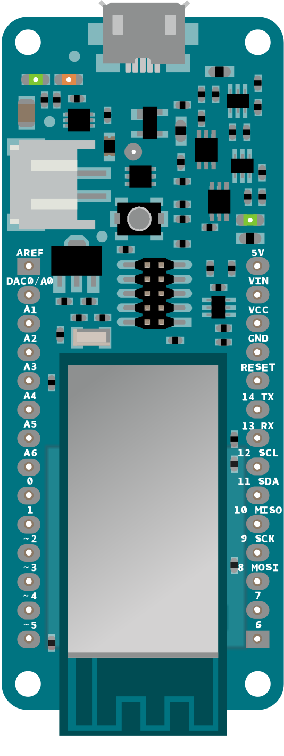

## FEATURES

* Microcontroller: Microchip SAMD21 32-bit Arm Cortex-M0+
* Transceiver: Microchip/Atmel ATA8520
* Board power supply (USB/VIN): 5V
* Supported batteries: 2x "AA" or 2x "AAA"
* Circuit operating voltage: 3.3V
* Digital I/O pins: 8
* PWM pins: 12
* UART: 1
* SPI: 1
* I2C: 1
* Analog input pins: 7 (ADC 8/10/12 bit)
* Analog output pins: 1 (DAC 10 bit)
* External interrupts: 8
* DC current per I/O pin: 7mA
* Flash Memory: 256KB
* SRAM: 32KB
* Clock Speed: 32.768kHz (RTC), 48MHz
* LEDs: 6
* USB: Full-Speed USB and embedded host
* Antenna connection: Micro U.FL connector
* Carrier frequency: 868MHz
* Working region: EU (RCZ1)
* Lenght: 67.64mm
* Width: 25mm
* Weight: 32gm

The MKR FOX 1200 Board can be powered by an external power pack using 2 "AA" or "AAA" batteries, and can operate for up to six months with typical usage. The Board can also be powered via a USB power source. Switching from one source to the other is done automatically. An onboard Micro U.FL connector is provided to allow connection to an external GSM Antenna.

[**Arduino Micro UFL Sigfox Antenna (X000016)**](https://www.mouser.in/access/?pn=485-X000016) is a GSM (850/900/1800/1900MHz) antenna ideal for use with the MKRFOX1200 Development Board. It easily connects to the Development Board via a Micro U.FL connector. This compact (130mm x 16mm x 5mm) antenna is lead free and RoHS compliant.

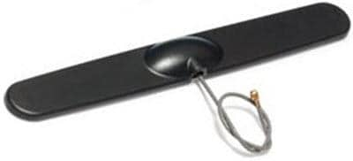

**WARNING:** Unlike most Arduino and Genuino boards, the MKR FOX 1200 runs at 3.3V. The maximum voltage that the I/O pins can tolerate is 3.3V. Applying voltages higher than 3.3V to any I/O pin could damage the board. While output to 5V digital devices is possible, bidirectional communication with 5V devices needs proper level shifting.

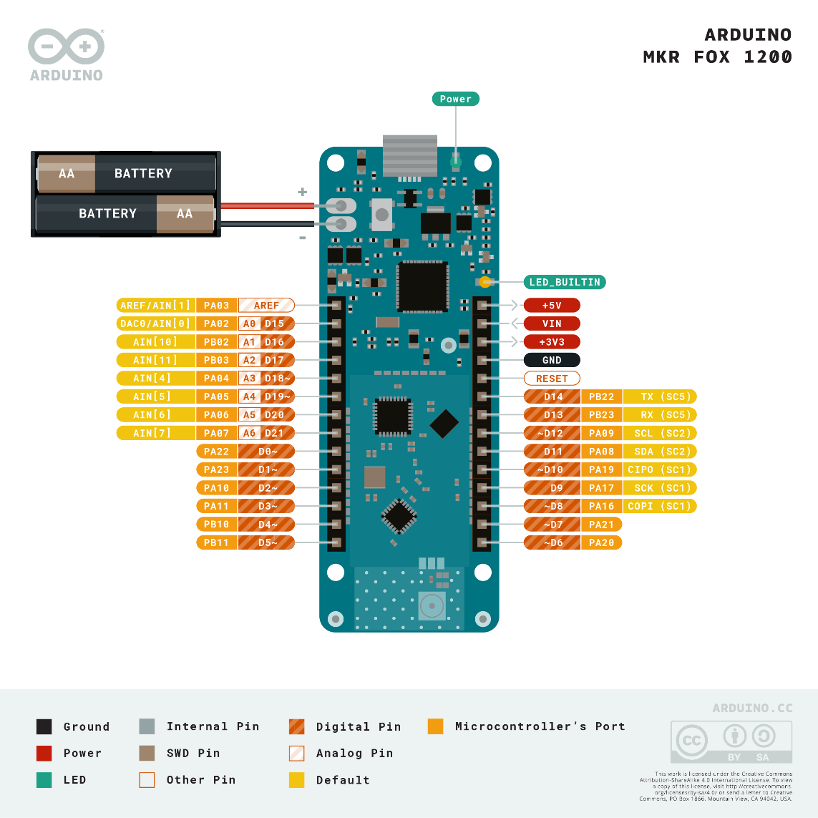

1. **MKR WAN 1300**

ARDUINO MKR WAN 1300 is a powerful board that combines the functionality of the MKR Zero and LoRa connectivity. It is the ideal solution for makers wanting to design IoT projects with minimal previous experience in networking having a low power device.

The Arduino MKR WAN 1300 board provides a practical and cost-effective solution to add LoRa connectivity to projects requiring low power. This open-source board can be connected to the Arduino IoT Cloud, your own LoRa network using the Arduino LoRa PRO Gateway, existing LoRaWAN infrastructure like The Things Network, or even other boards using the direct connectivity mode.

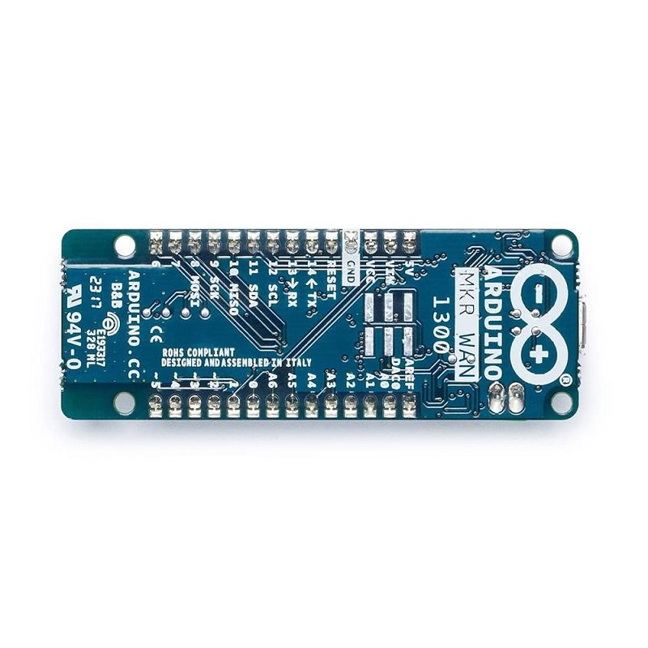

#### **Features:**

1. A revised version of the MKR 1300 including better battery control and an onboard Flash memory chip.
2. Based on the Microchip SAMD21 low power processor, the Murata CMWX1ZZABZ LoRa module, and the MKR family’s characteristic crypto chip (the ECC508).
3. Connect your MKR board to Arduino’s IoT Cloud, a simple and fast way to ensure secure communication for all of your connected things.

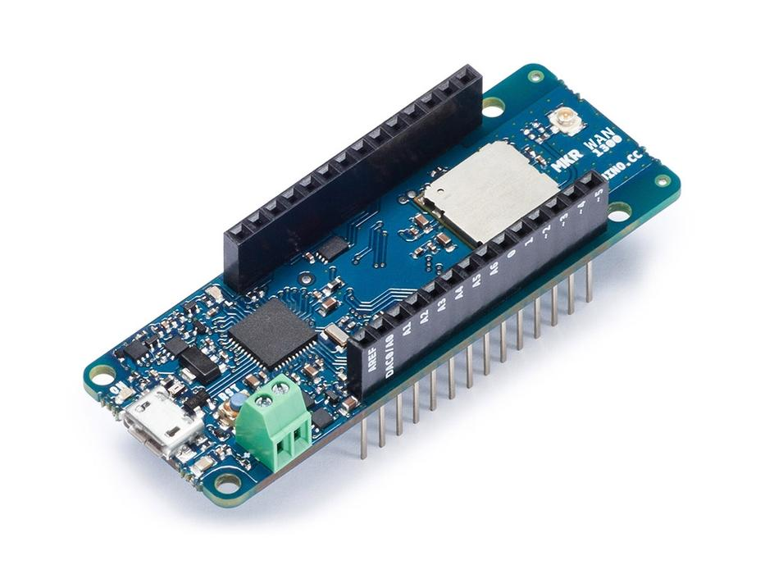

The design includes the ability to power the board using two 1.5V AA or AAA batteries or external 5V. Switching from one source to the other is done automatically. A good 32 bit computational power similar to the MKR ZERO board, the usual rich set of I/O interfaces, low power Lo-Ra communication and the ease of use of the Arduino Software (IDE) for code development and programming. All these features make this board the preferred choice for the emerging IoT battery-powered projects in a compact form factor. The USB port can be used to supply power (5V) to the board. The Arduino MKR WAN 1300 is able to run with or without the batteries connected and has limited power consumption.

**Warning: Unlike most Arduino & Genuino boards, the MKR WAN 1300 runs at 3.3V. The maximum voltage that the I/O pins can tolerate is 3.3V. Applying voltages higher than 3.3V to any I/O pin could damage the board. While output to 5V digital devices is possible, bidirectional communication with 5V devices needs proper level shifting.**

|  |  |
| --- | --- |
| **MICROCONTROLLER** | SAMD21 Cortex-M0+ 32bit low power ARM MCU |
| **RADIO MODULE** | CMWX1ZZABZ ([datasheet](https://wireless.murata.com/eng/type-abz.html)) |
| **BOARD POWER SUPPLY (USB/VIN)** | 5V |
| **SUPPORTED BATTERIES(*)** | 2x AA or AAA |
| **CIRCUIT OPERATING VOLTAGE** | 3.3V |
| **DIGITAL I/O PINS** | 8 |
| **PWM PINS** | 12 (0, 1, 2, 3, 4, 5, 6, 7, 8, 10, A3 - or 18 -, A4 -or 19) |
| **UART** | 1 |
| **SPI** | 1 |
| **I2C** | 1 |
| **ANALOG INPUT PINS** | 7 (ADC 8/10/12 bit) |
| **ANALOG OUTPUT PINS** | 1 (DAC 10 bit) |
| **EXTERNAL INTERRUPTS** | 8 (0, 1, 4, 5, 6, 7, 8, A1 -or 16-, A2 - or 17) |
| **DC CURRENT PER I/O PIN** | 7 mA |
| **FLASH MEMORY** | 256 KB |
| **SRAM** | 32 KB |
| **EEPROM** | no |
| **CLOCK SPEED** | 32.768 kHz (RTC), 48 MHz |
| **LED_BUILTIN** | 6 |
| **FULL-SPEED USB DEVICE AND EMBEDDED HOST** |  |
| **ANTENNA POWER** | 2dB |
| **CARRIER FREQUENCY** | 433/868/915 MHz |
| **WORKING REGION** | EU/US |
| **LENGTH** | 67.64 mm |
| **WIDTH** | 25 mm |
| **WEIGHT** | 32 gr. |

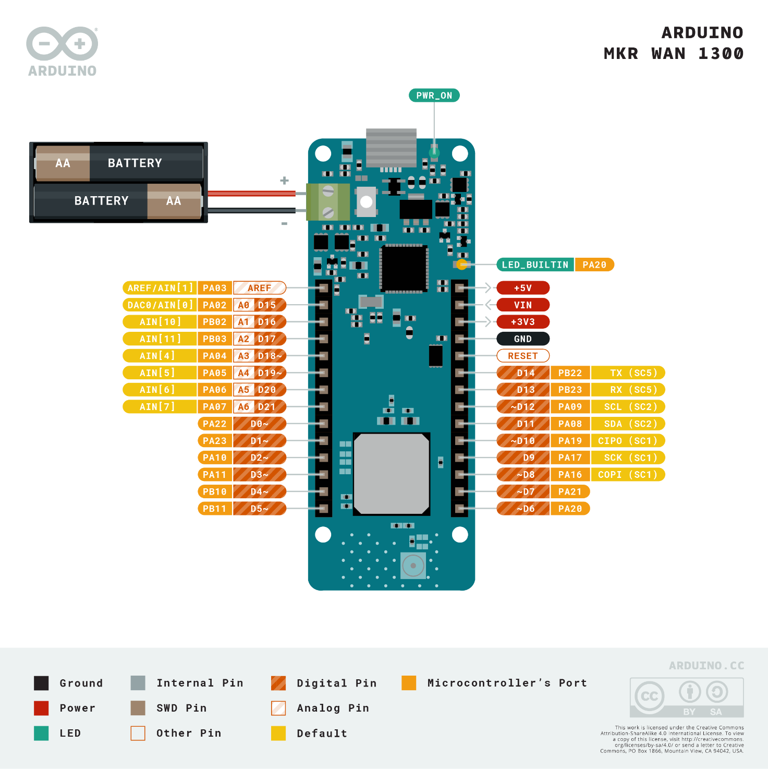

### Batteries, Pins and board LEDs

**Battery capacity:**The connected batteries must have a nominal voltage of 1.5V

**Battery connector:**If you want to connect a battery pack (2x AA or AAA) to your MKR WAN 1300 use the screw terminal block.

**Polarity** : as reported on the silk in the bottom of the board, positive pin is the closest to the USB connector

**Vin:**This pin can be used to power the board with a regulated 5V source. If the power is fed through this pin, the USB power source is disconnected. This is the only way you can supply 5v (range is 5V to maximum 6V) to the board not using USB. This pin is an INPUT.

**5V:**This pin outputs 5V from the the board when powered from the USB connector or from the VIN pin of the board. It is unregulated and the voltage is taken directly from the inputs.

**VCC:**This pin outputs 3.3V through the on-board voltage regulator. This voltage is 3.3V if USB or VIN is used and equal to the series of the two batteries when they are used

**LED ON:**This LED is connected to the 5V input from either USB or VIN. It is not connected to the battery power. This means that it lits up when power is from USB or VIN, but stays off when the board is running on battery power. This maximizes the usage of the energy stored in the battery. It is therefore normal to have the board properly running on battery power without the LED ON being lit.

**Onboard LED:**On MKR WAN 1300 the onboard LED is connected to **D6** and not D13 as on the other boards. Blink example or other sketcthes that uses pin 13 for on board LED may need to be changed to work properly.

Which microcontroller board will be useful for IoT application?

1. **Arduino MKR Series** IoT Boards. Arduino, the most used and most popular board for electronics development has killed it with its MKR family board. Arduino has launched 5 new development kits with in-built connectivity to ease the development of connected hardware products.

Which is the popular IoT board and can be called as a mini computer?

#1 **Raspberry Pi 4 Model B**  
  
Raspberry Pi is the most advanced and powerful board available in the market. It is mostly used by engineers and technologists for making small and big scale IoT projects. Raspberry Pi falls in the category of a single-board computer. Thus, they are also known as mini computers.

Which Arduino board is used for IoT?

The **Arduino Nano 33 IoT** is programmed using the Arduino Software (IDE), our Integrated Development Environment common to all our boards and running both online and offline.

This board is compatible with the Arduino IoT Cloud, where you can create IoT applications in a few simple steps. The cloud includes powerful features, such as building dashboards to monitor and control sensor networks, while making sure your data is secure.

Can Arduino Uno connect to IoT cloud?

Currently, Arduino IoT Cloud **only** supports the MKR 1000, MKR WiFi 1010 and the MKR GSM 1400 boards. In the future the MKR VIDOR 4000 and Arduino Uno boards will also be supported.

## [**Arduino Ethernet REV 3 - Best Arduino for IoT Projects**](https://www.electromaker.io/shop/product/arduino-ethernet-shield-2)

This [ATmega328-based microcontroller](https://www.electromaker.io/shop/product/arduino-ethernet-shield-2) boasts 14 digital I/O pins, 6 analog outputs, a 16 MHz crystal oscillator, power jack, and an RJ45 connector, or Ethernet port. Its optional Power over Ethernet (PoE) module may be tacked on for an Ethernet-powered board. There's an incorporated WizNet W5100 TCP/IP embedded Ethernet controller, making this a solid board for advanced Arduino users. For Internet of Things projects, the Arduino Ethernet Rev 3 not only hosts an Ethernet header, but there's a built-in microSD card reader for networked files.

*******************************************************************

When comparing Arduino board vs. Raspberry Pi for a simple single-action IoT application, memory storage maybe not the most important factor. However, if your IoT device is multifunctional, it may require substantial RAM.

As a microcontroller, Arduino has just enough memory to run a simple execution code. For example, Arduino UNO has only 32 K bytes of flash memory and 2 K bytes of SRAM.

Pis are small computers so they have much larger memory capacity. For example, the latest models are said to provide up to 8GB of SDRAM. It’s enough to run multiple functionalities for a more complex IoT system.

Connectivity capabilities are, probably, the most important features when it comes to building an IoT system using Arduino or Raspberry Pi boards.

The latest Raspberry Pi models have WiFi, Bluetooth, Ethernet connectivity installed by default, offer a pretty good speed and processing power which can handle video and audio data.

Arduino requires shields or modules to add basic connectivity options like WiFi, GPS or Bluetooth. Though it’s not complicated and takes just a few steps.

One of the most popular LPWRN options in IoT, LoRa can be easily connected to both Pi and Arduino with a special module.

Apart from original componentry, both Arduino and Raspberry Pi boards can be expanded to add features and functions to the system. This is where another important difference between these boards steps in.

Arduino is expanded with shields — boards installed on top of the main board using general pin headers. Shields allow adding on functionality like GPS, SD card, connection to the Internet via Ethernet, LCD display, etc. More than one shield can go on top as long as it’s properly connected. In this case, the hardware becomes a bit bulky and loses its portability features.

If you compare Arduino and Raspberry Pi, you’ll see that the latter has many of the previously mentioned features on the original board. The latest Raspberry Pi models have media and audio input/output, several connectivity options, SD port, and other features. Additional modules and accessories like camera, display and expansion boards (HAT, hardware attached on top) can also be installed.

## Best for

Now, let’s find out when each of the boards shines.

First of all, it would be wrong to say which one is better, Raspberry Pi or Arduino, because each of the boards has its own benefits and fundamental differences.

Both boards are great for prototyping. Arduino is easier to set up and go, while Raspberry Pi provides more onboard features.

### IoT Arduino

As a rule, Arduino is used in the systems with simple repetitive tasks that imply only a single action at a time. For example, using pins, you can connect to the board an analog sensor that monitors humidity in the room and program it to turn on a humidifier when the humidity level drops down to a certain level. In many cases, Arduino will be a more cost and effort efficient solution compared to Pi.

### IoT Raspberry Pi

Faster and more powerful Raspberry Pi can handle multitasking and run more complex functionality than Arduino. It includes running media playback, making calculations and collecting various parameters at the same time. So if an IoT system needs to collect data from several sensors, pull data from the Internet, connect to a smartphone and provide a complex output on a display, Raspberry Pi is the right option.

One more thing. The choice should not always be Arduino vs.Raspberry Pi. In fact, it can be confusing choosing between the two when both boards have their own pros and cons. Instead, these boards can perfectly work together if an IoT project requires so. For example, in an [IoT agriculture system](https://www.digiteum.com/iot-agriculture/), uncomplicated and cheap Arduino boards can be used to read measurements from multiple soil sensors, while a Raspberry Pi can work as a think tank and decide how to act on the data collected by sensors.

Why Arduino is most suitable for IoT applications?

Plus, with less moving points, Arduino boards **tend to be easier to maintain and much less likely to fail**. For IoT applications that are relatively simple in nature — particularly those that deploy hundreds to thousands of IoT-connected devices — choosing Arduino makes the most sense.

Which is more useful Arduino or Raspberry Pi?

[[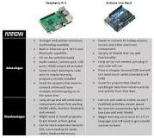](https://www.google.com/search?q=Which+is+more+useful+Arduino+or+Raspberry+Pi?&rlz=1C1CHBF_enIN854IN854&sxsrf=AOaemvL_kQLrDrCcJ8t7r6Hk7208kiRAhQ:1639124610687&tbm=isch&source=iu&ictx=1&fir=ZyKDEVDg6WNcsM%252C7qNaCAqKAZm-uM%252C_&vet=1&usg=AI4_-kRRCQMlgZWy2TYVVIa5i4-n9pdKWA&sa=X&ved=2ahUKEwiMnaWB59j0AhWPxzgGHbaFAhQQ9QF6BAgaEAE#imgrc=ZyKDEVDg6WNcsM)](https://www.google.com/search?q=Which+is+more+useful+Arduino+or+Raspberry+Pi?&rlz=1C1CHBF_enIN854IN854&sxsrf=AOaemvL_kQLrDrCcJ8t7r6Hk7208kiRAhQ:1639124610687&tbm=isch&source=iu&ictx=1&fir=ZyKDEVDg6WNcsM%252C7qNaCAqKAZm-uM%252C_&vet=1&usg=AI4_-kRRCQMlgZWy2TYVVIa5i4-n9pdKWA&sa=X&ved=2ahUKEwiMnaWB59j0AhWPxzgGHbaFAhQQ9QF6BAgaEAE" \l "imgrc=ZyKDEVDg6WNcsM)

The **Arduino Uno** has an easier time interfacing with analog sensors, motor, or other components, while the Raspberry Pi 3 has a more complicated path to get sensor readings (like installing libraries, software, and connecting to a monitor/keyboard/mouse).